Peptide Incorporation into PEG Hydrogels
  - Created By: Laura Simpson
  - 8/15/18

Purpose
By labeling the charged peptides with Alexa 488, the degree of incorporation of the peptide into the hydrogel may be determined.
 | Amount (mg) | MW (g/mol) | Excitation (nm) | Emission (nm) | Extinction coefficient (ε) (cm⁻¹ M⁻¹) | CF
Alexa 488 | 1 | 643.3 | 494 | 517 | 73,000 | 0.11

Code | Peptide Sequence | Charge | pI | MW (g/mol)
RGR | GCRGD-RGRGR | +3 | 11.93 | 1089.21
RDA | GCRGD-RDADR | 0 | 6.33 | 1120.17
DAD | GCRGD-DADAD | -3 | 3.43 | 993.97

Diagram
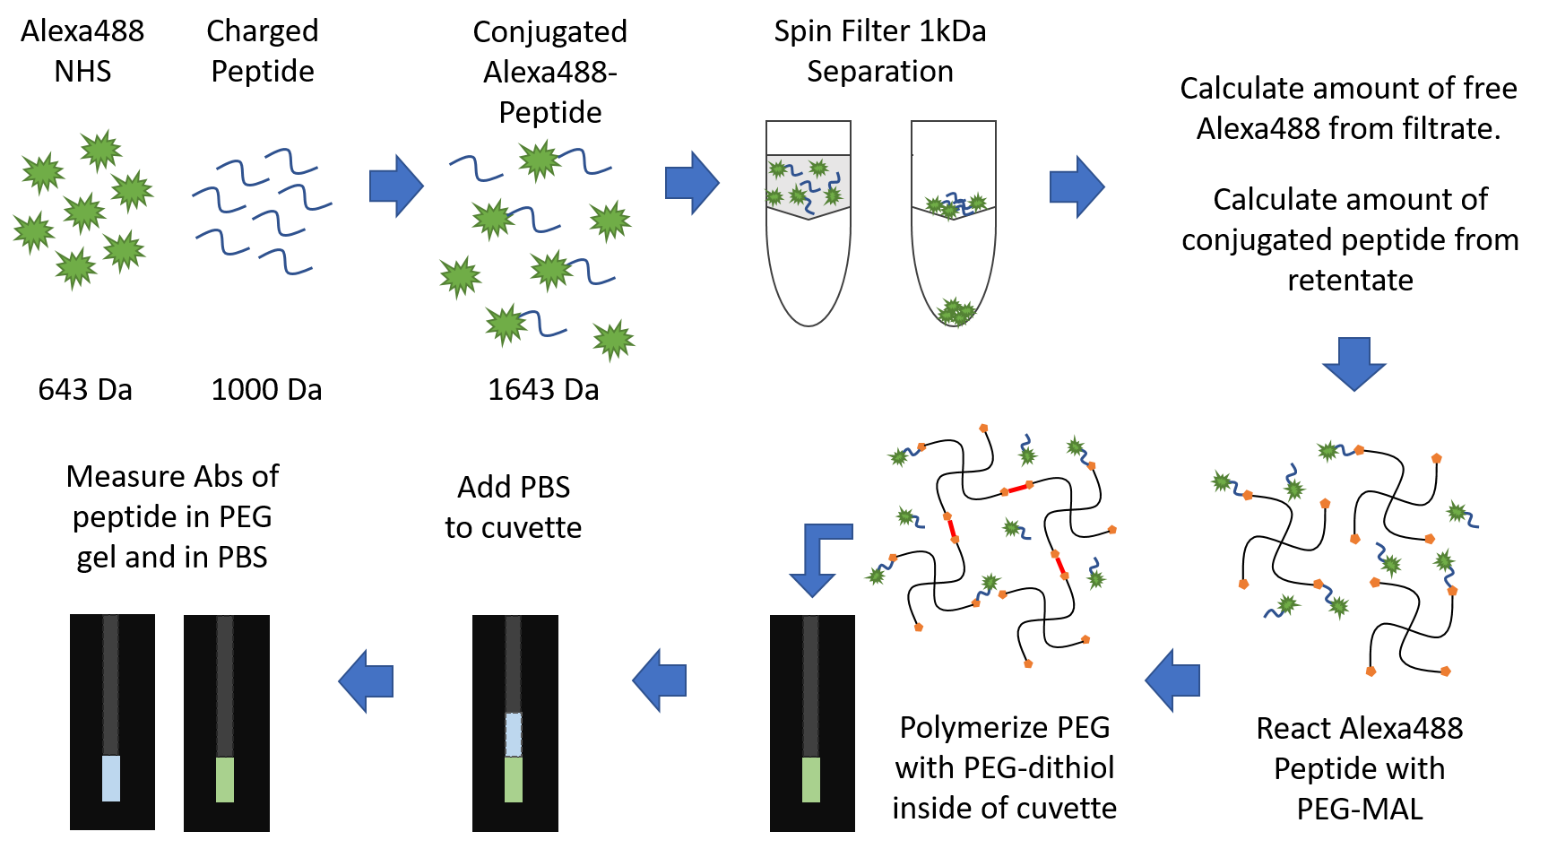

Materials

Alexa 488 NHS Ester
Charged peptide
Spin filter 1kDa cutoff
Sodium Bicarbonate
DMSO
PEG Maleimide
PEG Dithiol
Cuvettes
PBS
Pipettors
Pipette tips

Part 1: Alexa 488 NHS Ester Conjugation Protocol
- Day Before
  - Fill spin filter sample reservoir with 5 ml of 10% glycerine. Soak overnight at room temperature.
  - Prepare a 0.1 – 0.2 M pH 8.3 solution of sodium bicarbonate.
  - Prepare a dilute solution of HCL (~ 0.05 M). Fill a 15 ml tube with 13 ml of DI water then using a plastic transfer pipette, add 2 drops of concentrated HCL to the DI water.

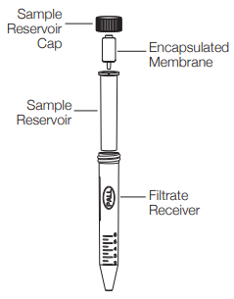
- Labeling
  - Dissolve 0.05 mg of charged peptide in 10 µl sodium bicarbonate 0.1 – 0.2 M, pH 8.3 to reach a final concentration of 5 mg/ml. Gently vortex to dissolve.
Note: Efficiency of the reaction will greatly decrease if the protein concentration is below 2 mg/ml.
  - Dissolve the 1 mg of Alexa 488 NHS Ester in 100 µl high purity DMSO. Keep the solution out of the light.
Note: Reactive compounds are not very stable in solution. Leftover material should be frozen in the -20˚C freezer right away. If you need to determine the CF described in section 3 wait to freeze until the incubation has started.
  - Add 6.4 µl of the Alexa 488 NHS Ester solution to the peptide solution and tape down to the vortexer set to level 4 for 1 hour. Wrap the tube with tin foil to protect the fluorophore from light during the incubation.
Note: The peptides are so small that even the peptide dye conjugate is not large enough to easily separate the free dye from the peptide dye conjugate using a spin column which is usually used for small volumes.
***During incubations go to sections 3, 4 and 5***
  - Remove the 10% glycerine from the spin filter sample reservoir and rinse with DI water.
  - Fill sample reservoir with DI water and spin. Repeat. Use within 20 minutes.
  - Add 1.5 ml to the sample tube so that there is enough volume for the spin filter to process.
  - Assemble the spin filter so that the filter insert is inside the 15 ml tube, then pipette the protein + dye solution into the filter insert area. Wrap the tube in tin foil to protect the fluorophore from light.
  - Take a 15 ml tube and add 2 ml of water to it to act as a balance on the centrifuge.
  - Centrifuge the solution on the spin filter for 60 min at 3,000 x g.
Note: The 1 kDa cutoff filter recommends for the use of 3 – 5 kDa proteins, our proteins are only 1.6 kDa so we are going to spin at the lowest value and a diluted concentration to try to retain our labeled protein.
  - Carefully pipette the concentrated solution inside the sample reservoir into a clean microcentrifuge tube. This solution should contain conjugated Alexa 488 peptide as well as some unlabeled peptide. Keep out of light by wrapping tube with tin foil.
What is the volume of the concentrated solution:
  - Add sodium bicarbonate to make the solution 100 µl.
  - Remove the sample reservoir from the device and cap the tube containing the filtrate which contains free Alexa 488 that did not label protein. Keep out of light by wrapping tube with tin foil.
What is the volume of the filtrate:

- Determining the CF
  - First set the spectrophotometer to read absorbance by pressing the “%T/A/RFU” button until Abs is on the screen. Set the ex. 220 nm.
  - Fill the 100 ul black quartz cuvette with 99 ul PBS. Put in the spectrophotometer and press “REF” to zero the spectrophotometer.
  - To determine the contribution of the dye (CF) to the Absorbance at A₂₂₀, pipette 1 µl of the Alexa 488 NHS Ester concentrate (10 mg/ml) into the 99 µl in the cuvette. Pipette up and down several times to mix thoroughly. This is a 155 µM solution.
  - On the spectrophotometer, insert the cuvette so that the path of light is facing left to right, then close the lid and press “Read Cuvette”.
A₂₂₀:
  - Fill the large black quartz cuvette with PBS and put in the spectrophotometer. Set ex. 494 nm and press “REF” to zero.
  - Set the Alexa 488 cuvette in the spectrophotometer and press “Read Cuvette”.
A₄₉₄:
A_{220 free dye}
A_{494 free dye}
CF = = Should be near 0.11

  - Save the Alexa 488 solution in the cuvette for the next step.

- Alexa 488 Standard Curve
  - From the Alexa 488 solution used in the CF determination at 155 µM. Dilute this solution to 100 µM by adding 55 µl PBS to the cuvette solution. Pipette up and down several times to mix.
  - Set the spectrophotometer to RFU, ex. 494 em. 517.
  - Fill the large quartz cuvette with PBS and put in the spectrophotometer and press REF.
  - Set the reference to the side and put the 100 µM sample in the spectrophotometer and “Read Cuvette”.
  - See the table in the Results section. Fill in the reading in the RFU column for 100 µM.
  - In the table, work from the bottom up. The 70 µM row states you need to add 66.429 µl PBS to the 155 µl in the cuvette to get 70 µM. Press “Read Cuvette” and input reading into RFU column.
  - Continue through the table, diluting the previous solution to read the next concentration. You will have to start taking the solution out of the cuvette and diluting it in a 15 ml tube to mix. Then add 100 µl back to the cuvette to read. Replace the 100 µl back to the diluted stock to continue the table of dilutions.
  - When the standard curve is complete, discard the solution and fill the cuvette with dilute HCL (~0.05 M). Let sit for 5 minutes and discard. Rinse the cuvette with DI water. Use the air nozzle on the bench top to remove any residual moisture from the cuvette.

- Determining the extinction coefficient
The extinction coefficient for the charged peptides must be determined. Normally protein absorbance is read at 280 nm to detect the tryptophan. These small peptides are devoid of tryptophan and therefore will have little to no absorbance read at 280 nm. We will read absorbance at 220 nm to detect the peptide bonds.
  - Take a 0.1 mg tube of charged peptide and dissolve it in 100 µl of sodium bicarbonate to get a concentration of 1 mg/ml.
1 (mg/ml)
MW (g/mol)
= C (mol/L) =

  - Put the solution into the 100 µl quartz cuvette, put it in the spectrophotometer with the read windows facing left to right and shut the lid.
  - On the key pad of the spectrophotometer, set the excitation to 220 nm and press “Read Cuvette”.
= ε₂₂₀ = cm⁻¹ M⁻¹
A₂₂₀
C (mol/L) ● 1 cm
A₂₂₀:
  - Pipette out the charged peptide solution back into its tube and freeze so that it can be lyophilized.
  - Clean the cuvette with 100 µl of dilute HCL solution (~0.05M). Let sit for 5 minutes. Remove the HCL and rinse the cuvette with DI water. Turn on the air nozzle on the bench to dry residual moisture in the cuvette.

- Determining the Degree of Labeling
  - Pipette 100 µl of the protein dye conjugate into the cuvette, put it into the spectrophotometer and close the lid.
  - Read the absorbance at 220 nm and at 494 nm.
A₂₂₀: A₄₉₄:
Note: If the Absorbance is above 1.5, remove the dye solution and return to the sample tube. Then pipette 90 µl of Sodium Bicarbonate into the cuvette and add 10 µl from the sample tube. Pipette to mix and repeat the readings. Repeat this until the Absorbance values are in a readable range.
A_{protein} = A₂₂₀ – A₄₉₄ (CF) =
A₂₂₀ ● df
ε₂₂₀
[Protein] = = (mol/L) ● MW (g/mol) = (mg/ml)
A₄₉₄ ● MW
[protein (mg/ml)] ● ε_{Alexa488}
[DOL] = =
  - Pipette out the protein dye conjugate solution and return to sample tube. Pipette to mix well.
  - Clean the cuvette with 100 µl of dilute HCL solution (~0.05M). Let sit for 5 minutes. Remove the HCL and rinse the cuvette with DI water. Turn on the air nozzle on the bench to dry residual moisture in the cuvette.
  - Calculate the total concentration of dye conjugated peptide in the sample tube.
[Protein (mg/ml)] ● Volume (ml) = mg
  - For the degree of incorporation experiment, a minimum of 0.0125 mg is needed. If all protein was collected in the sample tube (0.05mg), then it can be divided into 4 tubes of 0.0125 mg. If less separate into less equal portions.
Aliquot size: mg Number:
  - Aliquot the sample tube and freeze them to be lyophilized.

- Filtrate free dye concentration
  - Pipette 100 µl of the filtrate from the spin filter into the 100 µl quartz cuvette, put it in the spectrophotometer and shut the lid.
  - Set the spectrophotometer to excitation 494 nm and “Read Cuvette”.
A₄₉₄:
A₂₂₀ ● df
ε₂₂₀
[Dye] = = (mol/L) ● 643.4 (g/mol) = (mg/ml)
(mg/ml) ● ml = mg
Started with 0.097 mg Alexa 488. = %
( ) mg
0.097 mg
  - Set the spectrophotometer to excitation 220 nm and “Read Cuvette”. This is to determine if any protein passed through the 1 kDa filter.
A₂₂₀:
A₂₂₀ ● df
ε₂₂₀
[Protein] = = (mol/L) ● MW (g/mol) = (mg/ml)
(mg/ml) ● ml = mg
( ) mg
0.05 mg
Started with 0.05 mg of peptide. = %
  - Pipette the solution out of the cuvette and return it to the filtrate tube. Freeze solution for lyophilization.
  - Clean the cuvette with 100 µl of dilute HCL solution (~0.05M). Let sit for 5 minutes. Remove the HCL and rinse the cuvette with DI water. Turn on the air nozzle on the bench to dry residual moisture in the cuvette.
This labeling protocol should be conducted for each charged peptide: DAD, RDA, and RGR

Part 2: Peptide Incorporation Protocol
There is only one 100 µl quartz cuvette which means only one charged peptide may be tested at a time. The release of unlinked peptide should be tested over 24-72 h.
- Calculations
Aliquot of Alexa 488-DAD: mg
( ) µmol
200 µmol/L
( ) mg
MW g/mol
= µmol = µl
of PEG Mal to dissolve peptide in
Aliquot of Alexa 488-RDA: mg
= µmol = µl
( ) µmol
200 µmol/L
( ) mg
MW g/mol
of PEG Mal to dissolve peptide in
Aliquot of Alexa 488-RGR: mg
( ) µmol
200 µmol/L
( ) mg
MW g/mol
= µmol = µl
of PEG Mal to dissolve peptide in

PEG Mal (5% w/v) dissolved in 4 mM TEA pH 7.
= 1.5 x 10⁻⁷ x 4 = = 10 mM
(0.0006) mmol
60 µl
(0.003) g
20,000 g/mol
If you need more than 60 ul for the peptide than adjust the calculations
PEG dithiol 1:1 with PEG Mal, dissolved in 4 mM TEA pH 7.
(0.003) g
10,000 g/mol
(0.0006) mmol
60 µl
= 3x10⁻⁷ x 2 = = 10 mM
- Set-up Protocol
  - Prepare the PEG Mal and PEG dithiol solutions.
  - Fill the larger black quartz cuvette with µl of PBS to use as a control.
  - Wipe the cuvette windows with a Kim Wipe, and set in the spectrophotometer. On the spectrophotometer key pad, press the button “%T/A/RFU” until RFU is showing on the screen. Set the ex. 494 nm and em. 517 nm. Press “REF”. This will zero the spectrophotometer for PBS.
  - Dispose of the PBS and clean the cuvette using a dilute HCL solution (~0.05M). Let sit for 5 minutes. Remove the HCL and rinse the cuvette with DI water. Turn on the air nozzle on the bench to dry residual moisture in the cuvette.
  - Pipette the necessary volume of PEG Mal into the chosen charged peptide tube that will be tested in this experiment. Vortex on high to dissolve the peptide. Then sonicate for 5 minutes. Keep out of light by wrapping the tube in tin foil.
  - Tape the tube to the vortexer and turn on to level 4 for 30 minutes to react.
  - Pipette 50 µl of the PEG Mal solution into the 100 µl black quartz cuvette.
  - Pipette up 50 µl of PEG dithiol, and rapidly pipette the solution into the PEG MAL solution in the cuvette by pipetting up and down twice and pull the pipette tip out.
Note: Rapid gelation may cause the pipette tip to get stuck in the gel or will pull the gel out of the cuvette.
  - Let the gel react for 10 minutes. Cover the cuvette with tin foil to protect from the light.
  - Uncover the cuvette, wipe the cuvette windows with a Kim Wipe, and set in the spectrophotometer. On the spectrophotometer key pad, press the button “%T/A/RFU” until RFU is showing on the screen. Set the ex. 494 nm and em. 517 nm. Press “Read Cuvette”.
Time_0 RFU: Concentration: 100 µM
  - Pipette µl of PBS into the cuvette to cover the PEG gel. Cap the cuvette to prevent evaporation. Cover the cuvette with tin foil and place in a stable upright position at room temperature.

- Time Points
  - At 24 hours, fill the larger black quartz cuvette with PBS, put on the spectrophotometer, set to RFU and set the ex. 494 nm and em. 517 nm. Press REF.
  - Dump the PBS and use the air nozzle to dry the cuvette.
  - Uncover and uncap the 100 µl cuvette. Carefully remove the 200 µl of PBS resting above the gel and pipette into the larger volume black quartz cuvette.
Note: Be extra cautious not to pipette up the PEG gel, this may pull the whole gel out of the cuvette, stay to the walls and move the tip of the pipette tip with the height of the PBS in the cuvette.
  - Put the PBS cuvette in the spectrophotometer and press “Read Cuvette”. Input data into the table below.
  - Set the PBS cuvette to the side and cover with tin foil. Put the sample PEG gel cuvette in the spectrophotometer and press “Read Cuvette”. Input data into the table below.
  - With a syringe and blunt tip needle, collect the PBS from the large cuvette and return it to the PEG gel cuvette.
  - Cap the 100 µl black quartz cuvette with the PEG gel and PBS, wrap in tin foil and set in a stable upright position at room temperature.
  - Clean the larger cuvette with dilute HCL solution (~0.05 M). Let sit for 5 minutes. Remove the HCL and rinse the cuvette with DI water. Turn on the air nozzle on the bench to dry residual moisture in the cuvette.
  - Repeat steps 3.1 to 3.9 at time point 48 hr and 72 hr. Input data into the peptide incorporation table below.
  - When the experiment is finished, use the Teflon coated spatula to remove the PEG gel from the 100 µl black quartz cuvette.
  - Flush the cuvette with water to remove any pieces of gel.
  - Clean the cuvette with 400 µl of dilute HCL solution (~0.05 M). Let sit for 5 minutes. Remove the HCL and rinse the cuvette with DI water. Turn on the air nozzle on the bench to dry residual moisture in the cuvette.
***The next experiment testing a different charged peptide can now be started***

Results
Start with 100 µl PBS in the quartz cuvette to read the 0 µM during Part 1 Section 3 CF determination.
CF determination solution is 155 µM. Add 55 µl PBS to reach 100 µM and “Read Cuvette”
From the bottom up, the PBS column is how much PBS to add to the cuvette to dilute the previous solution.
You will end with a little over 3ml. The last few readings (20, 10 and 5 µM) you will have to remove the solution from the cuvette and dilute it in a 15 ml tube, then add 100 µl back to the cuvette to read.
Standard Curve
Concentration (µM) | PBS (µl) | RFU
0 | ---
5 | 1550
10 | 755
20 | 387.5
40 | 166.071
70 | 66.429
100 | 55

Peptide Incorporation Results
Use the Alexa 488 standard curve to determine the concentration of peptide retained in the PEG gel as well as the amount of peptide that has diffused out of the gel into the PBS.
Note: The standard curve will need to be converted from concentration of Alexa 488 to concentration of protein depending on the degree of dye labeling per peptide.
RGR
Time (hrs) | PEG Gel (RFU) | PBS (RFU)
0 |  | ---
24
48
72
RDA
Time (hrs) | PEG Gel (RFU) | PBS (RFU)
0 |  | ---
24
48
72
DAD
Time (hrs) | PEG Gel (RFU) | PBS (RFU)
0 |  | ---
24
48
72

